|  |  |
| --- | --- |
|  | **How to measure**  **with traditional and Bowlsline measures** |

**The correct way to measure with the Bowlsline string measure**

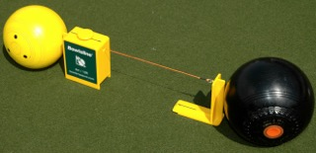

The principle of the fixed end touching the bowl first, and the adjustable end then taken to the jack, as with traditional string or metal measures, still applies, but both ‘ends’ **must be in line, square to the bowl and jack, and rest securely on the ground.**The result of the measure is the same i.e.   
String tight & not touching jack then 1st Measure On,   
String slack then 2nd Measure On. February 2018